5.101: a) The rock is released from rest, and so there is initially no resistive force and 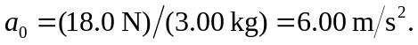
b) c) The net force must be 1.80 N, so 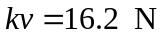 and d) When the net force is equal to zero, and hence the acceleration is zero, 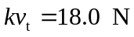 and e) From Eq. (5.12),
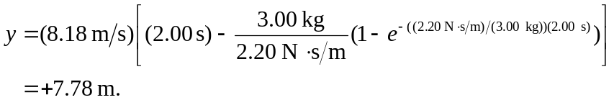
From Eq. (5.10),
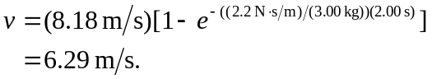
From Eq. (5.11), but with 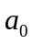 instead of g,
.
f)
